**[In Part 39, we have discussed the basics of views](http://csharp-video-tutorials.blogspot.com/2012/09/views-in-sql-server-part-39.html)**. In this session we will learn about Updateable Views. Let's create **tblEmployees**table and populate it with some sample data.   
  
   
  
   
  
   
  
**Create Table tblEmployee Script:**  
CREATE TABLE tblEmployee  
(  
  Id int Primary Key,  
  Name nvarchar(30),  
  Salary int,  
  Gender nvarchar(10),  
  DepartmentId int  
)  
  
**Script to insert data:**  
Insert into tblEmployee values (1,'John', 5000, 'Male', 3)  
Insert into tblEmployee values (2,'Mike', 3400, 'Male', 2)

Insert into tblEmployee values (3,'Pam', 6000, 'Female', 1)  
Insert into tblEmployee values (4,'Todd', 4800, 'Male', 4)  
Insert into tblEmployee values (5,'Sara', 3200, 'Female', 1)  
Insert into tblEmployee values (6,'Ben', 4800, 'Male', 3)  
  
**Let's create a view**, which returns all the columns from the tblEmployees table, except Salary column.  
Create view vWEmployeesDataExceptSalary  
as  
Select Id, Name, Gender, DepartmentId  
from tblEmployee  
  
**Select data from the view**: A view does not store any data. So, when this query is executed, the database engine actually retrieves data, from the underlying tblEmployee base table.  
Select * from vWEmployeesDataExceptSalary  
  
**Is it possible to Insert, Update and delete rows**, from the underlying tblEmployees table, using view vWEmployeesDataExceptSalary?  
**Yes**, SQL server views are updateable.  
  
**The following query updates, Name column from Mike to Mikey**. Though, we are updating the view, SQL server, correctly updates the base table tblEmployee. To verify, execute, SELECT statement, on tblEmployee table.  
Update vWEmployeesDataExceptSalary   
Set Name = 'Mikey' Where Id = 2  
  
**Along the same lines**, it is also possible to insert and delete rows from the base table using views.  
Delete from vWEmployeesDataExceptSalary where Id = 2

Insert into vWEmployeesDataExceptSalary values (2, 'Mikey', 'Male', 2)  
  
**Now, let us see, what happens if our view is based on multiple base tables**. For this purpose, let's create tblDepartment table and populate with some sample data.  
**SQL Script to create tblDepartment table**  
CREATE TABLE tblDepartment  
(  
 DeptId int Primary Key,  
 DeptName nvarchar(20)  
)  
  
**Insert data into tblDepartment table**  
Insert into tblDepartment values (1,'IT')  
Insert into tblDepartment values (2,'Payroll')  
Insert into tblDepartment values (3,'HR')  
Insert into tblDepartment values (4,'Admin')  
  
**Create a view which joins tblEmployee and tblDepartment tables**, and return the result as shown below.  
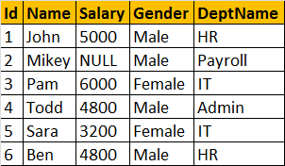  
  
**View that joins tblEmployee and tblDepartment**  
Create view vwEmployeeDetailsByDepartment  
as  
Select Id, Name, Salary, Gender, DeptName  
from tblEmployee  
join tblDepartment  
on tblEmployee.DepartmentId = tblDepartment.DeptId  
  
**Select Data from view vwEmployeeDetailsByDepartment**  
Select * from vwEmployeeDetailsByDepartment  
  
**vwEmployeeDetailsByDepartment Data:**  
  
  
  
**Now, let's update, John's department, from HR to IT**. At the moment, there are 2 employees (Ben, and John) in the HR department.  
Update vwEmployeeDetailsByDepartment   
set DeptName='IT' where Name = 'John'  
  
**Now, Select data from the view vwEmployeeDetailsByDepartment:**  
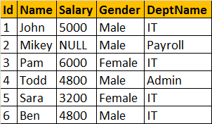  
  
**Notice, that Ben's department is also changed to IT**. To understand the reasons for incorrect UPDATE, select Data from tblDepartment and tblEmployee base tables.   
  
**tblEmployee Table**  
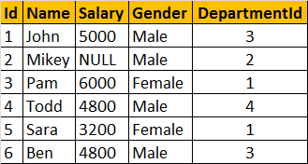  
  
**tblDepartment**  
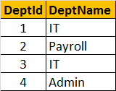  
  
  
**The UPDATE statement, updated DeptName from HR to IT in tblDepartment table**, instead of upadting **DepartmentId** column in **tblEmployee** table. So, the conclusion - If a view is based on multiple tables, and if you update the view, it may not update the underlying base tables correctly. To correctly update a view, that is based on multiple table, INSTEAD OF triggers are used.  
  
We will discuss about triggers and correctly updating a view that is based on multiple tables, in a later video session.